2020 had least road accident, due to COIVD lockdown and almost 2 months less in data collection

‘Collision with vehicle’ is the highest accident type across 5 years. 2016 had the first one, 2017 and 2018 had came down in numbers. Then 2019 the collision rate climb up again.

‘Collision with fixed object’ is the second highest accident type.

The ‘Struck pedestrian’ is the third common accident type. The rate was much declined over the year.

|  |  |  |  |
| --- | --- | --- | --- |
| **Accident Type per Year** |  |  |  |
| **ACCIDENTYEAR** | **ACCIDENT_TYPE** | **ACCT_TYPE_DESC** | **ACCIDENT_NO** |
| 2016 | 1 | Collision with vehicle | 10080 |
| 2016 | 2 | Struck Pedestrian | 1319 |
| 2016 | 3 | Struck animal | 192 |
| 2016 | 4 | Collision with a fixed object | 2519 |
| 2016 | 5 | collision with some other object | 179 |
| 2016 | 6 | Vehicle overturned (no collision) | 755 |
| 2016 | 7 | Fall from or in moving vehicle | 74 |
| 2016 | 8 | No collision and no object struck | 718 |
| 2016 | 9 | Other accident | 16 |
| 2017 | 1 | Collision with vehicle | 8642 |
| 2017 | 2 | Struck Pedestrian | 1164 |
| 2017 | 3 | Struck animal | 93 |
| 2017 | 4 | Collision with a fixed object | 2147 |
| 2017 | 5 | collision with some other object | 109 |
| 2017 | 6 | Vehicle overturned (no collision) | 645 |
| 2017 | 7 | Fall from or in moving vehicle | 63 |
| 2017 | 8 | No collision and no object struck | 525 |
| 2017 | 9 | Other accident | 5 |
| 2018 | 1 | Collision with vehicle | 8317 |
| 2018 | 2 | Struck Pedestrian | 1155 |
| 2018 | 3 | Struck animal | 130 |
| 2018 | 4 | Collision with a fixed object | 2042 |
| 2018 | 5 | collision with some other object | 122 |
| 2018 | 6 | Vehicle overturned (no collision) | 543 |
| 2018 | 7 | Fall from or in moving vehicle | 68 |
| 2018 | 8 | No collision and no object struck | 409 |
| 2018 | 9 | Other accident | 11 |
| 2019 | 1 | Collision with vehicle | 9491 |
| 2019 | 2 | Struck Pedestrian | 1231 |
| 2019 | 3 | Struck animal | 144 |
| 2019 | 4 | Collision with a fixed object | 2019 |
| 2019 | 5 | collision with some other object | 163 |
| 2019 | 6 | Vehicle overturned (no collision) | 566 |
| 2019 | 7 | Fall from or in moving vehicle | 164 |
| 2019 | 8 | No collision and no object struck | 375 |
| 2019 | 9 | Other accident | 11 |
| 2020 | 1 | Collision with vehicle | 3831 |
| 2020 | 2 | Struck Pedestrian | 441 |
| 2020 | 3 | Struck animal | 68 |
| 2020 | 4 | Collision with a fixed object | 994 |
| 2020 | 5 | collision with some other object | 83 |
| 2020 | 6 | Vehicle overturned (no collision) | 372 |
| 2020 | 7 | Fall from or in moving vehicle | 25 |
| 2020 | 8 | No collision and no object struck | 235 |
| 2020 | 9 | Other accident | 11 |

2016 had the highest fatal rate, 2019 was the second, 2017 was the third.

2016 had the most serious injury, then the ratio declined in a good ratio years after.

2019 had the highest ‘other injury’ type.

2020 had 111 days in lock down for Victorians, and 2 months less of data collection. The fatal rate is quite high in comparing to other years. According to some 2020 news reports at the time, the lockdown had created some stress and mental issues to people.

|  |  |  |  |
| --- | --- | --- | --- |
| **Severity Level in Accident per Year** | |  |  |
| **ACCIDENTYEAR** | **SEVERITY** | **SEVERITY_DESC** | **ACCIDENT_NO** |
| 2016 | 1 | Fatal accident | 275 |
| 2016 | 2 | Serious injury accident | 4925 |
| 2016 | 3 | Other injury accident | 10651 |
| 2017 | 1 | Fatal accident | 240 |
| 2017 | 2 | Serious injury accident | 4384 |
| 2017 | 3 | Other injury accident | 8769 |
| 2018 | 1 | Fatal accident | 202 |
| 2018 | 2 | Serious injury accident | 3759 |
| 2018 | 3 | Other injury accident | 8835 |
| 2019 | 1 | Fatal accident | 248 |
| 2019 | 2 | Serious injury accident | 2889 |
| 2019 | 3 | Other injury accident | 11027 |
| 2020 | 1 | Fatal accident | 140 |
| 2020 | 2 | Serious injury accident | 1742 |
| 2020 | 3 | Other injury accident | 4178 |

As the pie chart shows, road user gender Male has the highest fatal in comparing to female, 1.7 times more than the total fatal rate of female and unknown. Data show 861, 314 and 4 people respective.

|  |  |
| --- | --- |
| **Road User Gender Fatality counts** | |
| **SEX** | **ACCIDENT_NO** |
| F | 314 |
| M | 861 |
| U | 4 |

Male drivers have more accidents than female, the ratio is male 45% more than female.

Female road users are more in passenger’s roles.

More male motorcyclist have accident than females, the ratio is male 10 times more than females.

|  |  |  |
| --- | --- | --- |
| **4. Road User Type base on Gender** | |  |
| **SEX** | **ROAD_USER_TYPE_DESC** | **ACCIDENT_NO** |
| F | Bicyclists | 1507 |
| F | Drivers | 36992 |
| F | Motorcyclists | 730 |
| F | Passengers | 15546 |
| F | Pedestrians | 2822 |
| F | Pillion Passengers | 233 |
| F | Unknown | 439 |
| M | Bicyclists | 4554 |
| M | Drivers | 53589 |
| M | Motorcyclists | 8061 |
| M | Passengers | 12070 |
| M | Pedestrians | 3046 |
| M | Pillion Passengers | 81 |
| M | Unknown | 672 |
| U | Bicyclists | 118 |
| U | Drivers | 2427 |
| U | Motorcyclists | 162 |
| U | Passengers | 3008 |
| U | Pedestrians | 185 |
| U | Pillion Passengers | 17 |
| U | Unknown | 2098 |

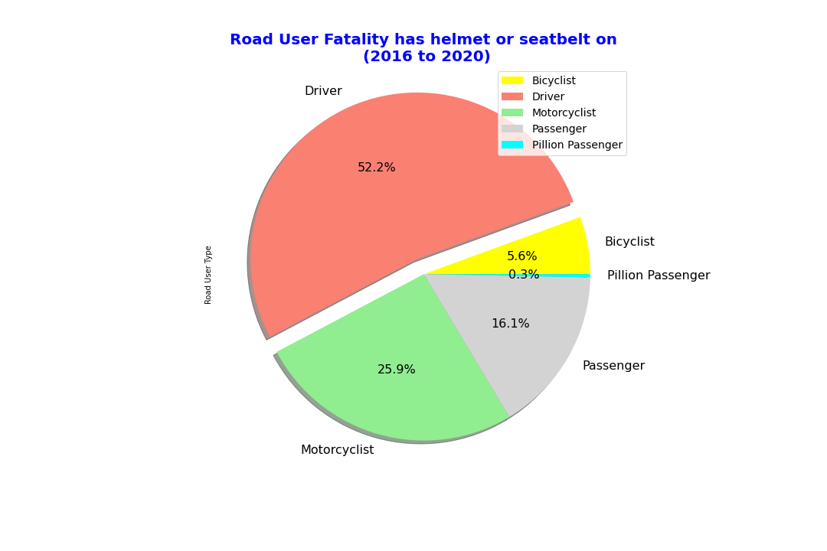

With seatbelt or helmet on, road user drivers have highest fatal rate, second is motorcyclists, then passengers.

Motorcyclist’s rate is almost of half the drivers, but in comparing to the total road user type population, motorcyclist has higher fatal rate than driver.

|  |  |
| --- | --- |
| **Road User Fatality With Helmet/Seatbelt** | |
| ROAD_USER_TYPE_DESC | ACCIDENT_NO |
| Bicyclists | 36 |
| Drivers | 337 |
| Motorcyclists | 167 |
| Passengers | 104 |
| Pillion Passengers | 2 |

Without wearing seatbelt or helmet, road user drivers have highest fatal rate, second is pedestrians, then passengers.

Pedestrians are quite vulnerable, more than 3 quarter of the driver’s rate.

|  |  |
| --- | --- |
| **Road User Fatality No Helmet /Seatbelt** | |
| ROAD_USER_TYPE_DESC | ACCIDENT_NO |
| Bicyclists | 12 |
| Drivers | 231 |
| Motorcyclists | 27 |
| Passengers | 78 |
| Pedestrians | 179 |
| Pillion Passengers | 1 |
| Unknown | 5 |

Unknown injury levels had been dropped in this analysis, they are the outliers.

Driver type has highest fatal rate, second is motorcyclist, then passengers.

Drivers have the highest total injury rate, second is the passengers, then motorcyclist, fourth is pedestrians who are quite vulnerable.

|  |  |  |  |
| --- | --- | --- | --- |
| **7. Road User Injury Level** |  |  |  |
| **ROAD_USER_TYPE_DESC** | **INJ_LEVEL_DESC** | **ACCIDENT_NO** |  |
| Bicyclists | Fatality | 48 | 6180 |
| Bicyclists | Not injured | 128 |  |
| Bicyclists | Other injury | 4542 |  |
| Bicyclists | Serious injury | 1461 |  |
| Bicyclists | Unknown | 1 |  |
| Drivers | Fatality | 568 | 93020 |
| Drivers | Not injured | 49435 |  |
| Drivers | Other injury | 32921 |  |
| Drivers | Serious injury | 10086 |  |
| Drivers | Unknown | 10 |  |
| Motorcyclists | Fatality | 194 | 8955 |
| Motorcyclists | Not injured | 277 |  |
| Motorcyclists | Other injury | 5187 |  |
| Motorcyclists | Serious injury | 3296 |  |
| Motorcyclists | Unknown | 1 |  |
| Passengers | Fatality | 182 | 30624 |
| Passengers | Not injured | 16227 |  |
| Passengers | Other injury | 10903 |  |
| Passengers | Serious injury | 3312 |  |
| Pedestrians | Fatality | 179 | 6053 |
| Pedestrians | Not injured | 230 |  |
| Pedestrians | Other injury | 3529 |  |
| Pedestrians | Serious injury | 2115 |  |
| Pillion Passengers | Fatality | 3 | 336 |
| Pillion Passengers | Not injured | 65 |  |
| Pillion Passengers | Other injury | 161 |  |
| Pillion Passengers | Serious injury | 102 |  |
| Unknown | Fatality | 5 | 3210 |
| Unknown | Not injured | 2754 |  |
| Unknown | Other injury | 344 |  |
| Unknown | Serious injury | 106 |  |
| Unknown | Unknown | 1 |  |